**LACHOO MEMORIAL COLLEGE OF SCIENCE & TECHNOLOGY(AUTONOMOUS)**

**BCA 6th Semester Project Synopsis Format**

1. Supervisor Name : DR. PRABHAT MATHUR
2. Topic : Institute Management System
3. GROUP MEMBER NAMES :-

|  |  |  |  |  |
| --- | --- | --- | --- | --- |
| **NAME** | **SECTION** | **GROUP** | **CONTACT** | **EMAIL** |
| Dinesh Solanki | A | A2 | 76665138089 | DineshSolanki@gmx.us |
| Ashok Suthar | A | A1 | 8502910894 |  |
| Amitabh Kalla | A | A1 | 9828018108 | amitabhkalla17@gmail.com |
| Chhotu Singh Rathore | A | A2 |  |  |

1. Introduction & objective of the project: -

Introduction:-

The IMS is an academic Institute management windows software, it aims to automate and ease most of the task of any academic institute, it can handle student details as well as staff and can keep track of Fee structure and can provide detail statistics by month, due, or class. The Software can create reports of student’s stats or staff’s and other required reports such as a Fee Receipt.

Objective of the Project:-

• To automate and ease Tasks

• Clean and User Friendly UI

• Consistent in terms of design as well as output

• Various Information Handling

• Role Based Access

1. Advantage: -

No more hassle of wasting hours finding Papers, or clusters managing in your PC, IMS Database can handle all this efficiently and nicely from pictures to Text, all in one database

-The Software Provides 7 Modules for better operations and work efficiency –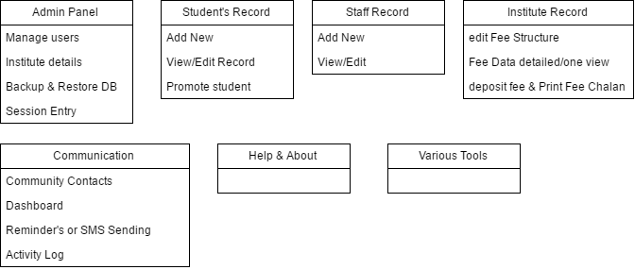

- And off course you can Search Every Data with multiple filters.

1. Tools / Environment used in Project :-
2. IDE: Visual Studio 2013
3. .NET UI Controls: DevExpress16
4. Operating System: Windows.
5. Back-End: MS SQL.
6. Front-End: VB.Net.